Dr. Babasaheb Ambedkar Marathwada University, Aurangabad

Details of the Gender Sensatization Programmes

Girls Common Room (Dept. of Chemistry)

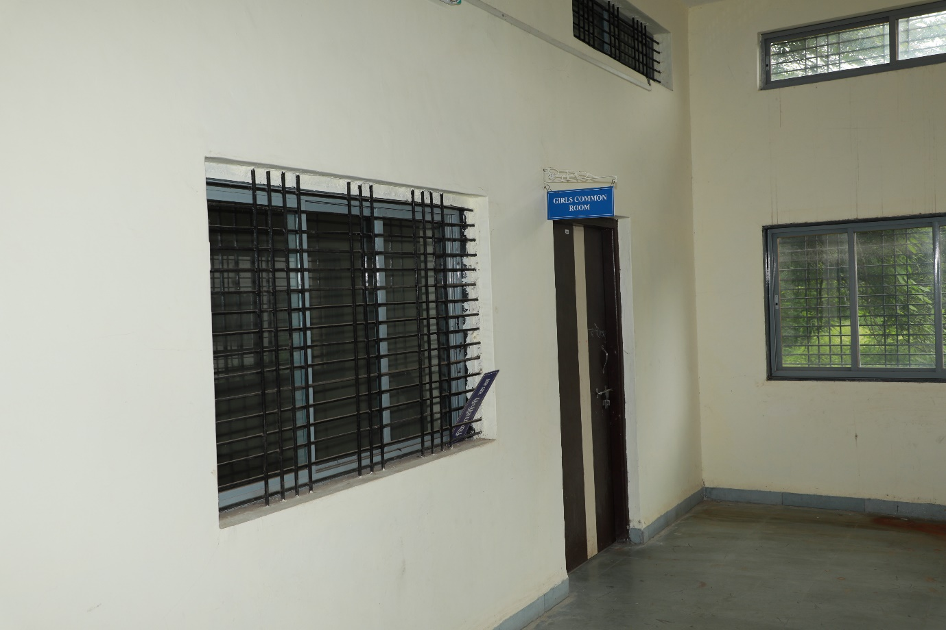

Counselling Room (Dept. of Psychology)

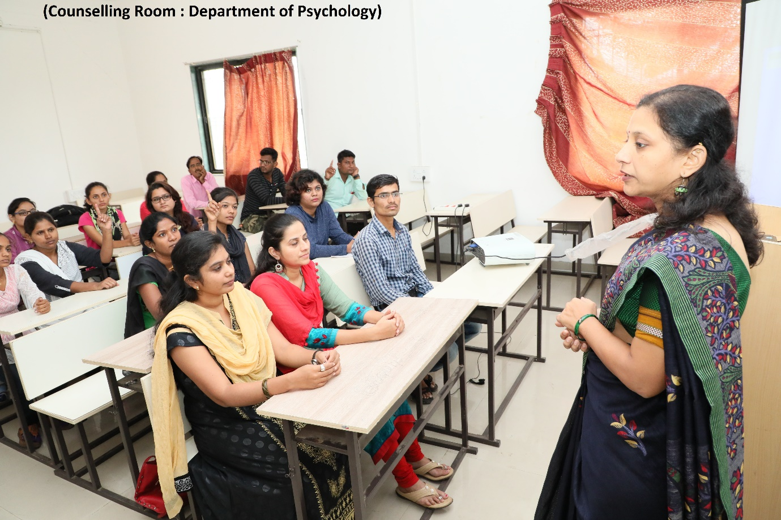

Gender Sensatization Programme
